Uneven Science–Policy Translation Shapes Global AI Governance
Tambudzai Charumbira (Gundani) and Joshua Gray
Master of Science in Data Science | Columbian College of Arts and Sciences
The George Washington University | Spring 2026
ABSTRACT

Artificial intelligence is transforming industries and societies at unprecedented speed, yet governance research has struggled to keep pace — and no systematic, spatially grounded map exists of how AI governance concerns are framed across regions, institutions, and policy frameworks. This study applies a reproducible, data-driven NLP framework to two complementary corpora: 41,067 peer-reviewed AI publications indexed in Scopus (2015–2025) and 35 national AI strategy documents spanning five world regions. Using a two-stage BERTopic pipeline combined with zero-shot stance classification (BART-large-MNLI), we identify 21 governance-relevant themes and examine their temporal, regional, and policy distributions. We find that only 7.8% of AI publications address governance. The post-ChatGPT period saw governance research surge in volume while shifting toward opportunity-dominant framing (40.0% vs 29.4% risk), suggesting a reorientation toward institutional design. Regional analysis reveals systematic specialization: Africa and the Middle East concentrate on cybersecurity governance at three times the European rate, while Latin America leads globally in AI and journalism discourse. Of 21 governance topics, 11 are absent from national AI strategies, a substantial knowledge-policy gap. Most strikingly, the EU AI Act vocabulary has emerged as the de facto global standard, structuring governance discourse in jurisdictions with no binding obligation to adopt European norms. The framework developed here is systematic, adaptable, and open-source: the same pipeline can be applied to map discourse in any domain where academic and policy literatures co-exist, supporting ongoing monitoring as new publications and policies emerge.
Keywords: AI governance; topic modelling; BERTopic; spatial NLP; policy discourse; risk framing; EU AI Act; bibliometrics

1. INTRODUCTION
The rapid development of artificial intelligence has reshaped industries, institutions, and public life at a pace that few technologies have matched. AI systems now mediate access to employment, credit, healthcare, criminal justice, and public services — and their reach continues to expand. Yet the governance frameworks meant to guide this transformation have struggled to keep pace. Questions about who governs these systems, according to whose values, and with what effects on different populations, have become among the defining policy challenges of the early 21st century. The public release of ChatGPT in November 2022 compressed what might have been a decade of gradual regulatory development into a few turbulent years, generating immediate and wide-ranging governance concerns across research, policy, and practice (Dwivedi et al., 2023).
Two broad bodies of work have attempted to map the AI governance landscape. Bibliometric studies document the geographic concentration of AI research output in a small number of high-income countries and elite institutions (Klinger et al., 2021). Ethics and policy scholarship catalogs the proliferation of AI principles documents, finding convergence on themes such as fairness, transparency, accountability, and privacy. Both traditions, however, share a critical limitation: they describe where research originates or what principles it invokes, but not how AI governance concerns are substantively framed, which risks are foregrounded, whether AI is positioned as a threat to be regulated or an opportunity to be harnessed, and how these framings vary across regions and between academic experts and formal governance institutions.
This paper addresses that gap. We apply a spatial NLP framework to 41,067 peer-reviewed AI publications (Scopus, 2015–2025) and 35 national AI strategy documents spanning five major world regions. Using BERTopic (Grootendorst, 2022), we identify dominant governance themes, trace their evolution before and after the emergence of generative AI, map their spatial distribution across regions and institutions, and compare academic and policy discourse. We complement topic analysis with zero-shot stance classification to distinguish risk-focused from opportunity-focused governance narratives.
The study is organized around three research objectives. RO1 asks what the dominant AI governance themes are, how they have evolved, and whether they are framed as risks, opportunities, or as a balance. RO2 examines how governance discourse is distributed spatially across world regions and contributing institutions. RO3 compares academic and policy corpora to identify convergence and divergence.
Several findings warrant immediate attention. Governance remains a minority concern: only 7.8% of AI publications explicitly address it. Yet the post-ChatGPT period saw this small field undergo a striking transformation — surging in total volume while simultaneously shifting its framing. The percentage of risk-focused research fell from 34.9% to 29.7%, while opportunity-focused research rose from 29.7% to 40.0%, suggesting scholars reoriented toward constructive institutional design rather than problem identification. This shift was not geographically uniform: Africa and the Middle East produce three times as much cybersecurity governance research as Europe, while Latin America leads globally in AI and journalism discourse. Perhaps most consequential, the EU AI Act's vocabulary has become the de facto global standard, structuring policy discourse even in jurisdictions with no binding obligation to adopt European norms.
2. LITERATURE REVIEW
2.1 AI Governance: Evolution, Regional Asymmetries, and the Limits of Principles
AI governance has undergone a structural transformation over the past decade: from voluntary ethics guidelines to binding regulatory instruments. Jobin et al. (2019) cataloged 84 AI ethics documents and found convergence on five core principles: transparency, fairness, non-maleficence, responsibility, and privacy. Mittelstadt (2019), however, argued that principles alone cannot constitute governance, observing that most frameworks lack enforcement mechanisms or concrete guidance for navigating competing values. The proliferation of principles without accountability has since been characterized as ethics washing: the performance of ethical commitments without substantive constraints on system design (Bietti, 2020).
The introduction of ChatGPT heightened regulatory urgency, prompting governments to move from articulating principles to taking binding action. The EU Artificial Intelligence Act (European Parliament, 2024), the most comprehensive regulatory framework to date, establishes a risk-based classification system with obligations calibrated to the severity of potential harm. Its global reach extends well beyond the EU through the Brussels effect, by which market access conditions incentivize non-EU actors to align with European standards (Bradford, 2020).
Geographic disparities in governance participation have attracted growing attention. Corrêa et al. (2023) analyzed 200 AI governance guidelines globally, finding that high-income-country documents emphasize abstract principles, whereas those from lower-income contexts foreground digital infrastructure, data sovereignty, and economic dependency. Hagendorff (2020) argued that the underrepresentation of diverse perspectives in AI ethics guideline development risks producing principles that fail to address structural inequalities. Eubanks (2018) and Noble (2020) documented how algorithmic systems reproduce racial and economic hierarchies, suggesting that representation in governance is a substantive determinant of whose vulnerabilities are addressed.
2.2 Computational Approaches to Governance Discourse
Topic modeling has proven particularly valuable for identifying latent thematic structures in large governance corpora. Blei et al. (2003) introduced Latent Dirichlet Allocation (LDA), which became foundational for computational text analysis. Grootendorst (2022) advanced the field with BERTopic, which uses pre-trained transformer embeddings, UMAP dimensionality reduction, and HDBSCAN clustering to produce semantically coherent topics superior to LDA for short texts and domain-specific corpora (Egger & Yu, 2022). The selection of BERTopic in this study is methodologically motivated: the combination of short abstracts, domain-specific vocabulary, and a heterogeneous 41,067-document corpus makes transformer-based approaches better suited than bag-of-words alternatives.
Navaratna & Saxena (2025) applied topic modeling to national AI policy documents, finding significant variation in how countries frame AI priorities, but their single-corpus approach precluded comparison with academic discourse and lacked spatial granularity. Ferjani et al. (2025) introduced a framework for mapping AI governance principles across documents, but it remained at the level of classification rather than enabling regional attribution. The present study advances beyond these contributions by integrating both corpora, attributing discourse to regions through institutional metadata, and examining temporal dynamics across a decade.
Framing theory provides a theoretical complement to computational methods. Entman (1993) defined framing as the selection and emphasis of aspects of perceived reality to promote particular problem definitions and treatment recommendations. In AI governance, whether systems are framed as risks or opportunities shapes which regulatory interventions appear necessary and which populations are understood as vulnerable or as beneficiaries. Nisbet (2009) demonstrated that issue framing systematically influences how expert audiences interpret technological risks, grounding the zero-shot stance classification employed here in an established theoretical tradition.
Bibliometric approaches reveal where research originates, but not what governance priorities it articulates (Waltman, 2016). Survey-based approaches impose predefined categories rather than allowing themes to emerge inductively (Tahaei et al., 2024). Single-corpus NLP studies lack the comparative dimension needed to assess knowledge-policy alignment. This study addresses the gap at the intersection of these limitations by integrating transformer-based topic modeling, geographic inference from institutional metadata, and stance classification into a unified pipeline applied simultaneously to academic and policy corpora.
3. METHODOLOGY
3.1 Corpora and Data Collection
The academic corpus was constructed through a systematic Scopus query capturing publications at the intersection of artificial intelligence and governance, ethics, risk, regulation, policy, fairness, accountability, and transparency. After deduplication and exclusion of records with fewer than 50 usable abstract words, the corpus comprises 41,067 publications from 138 countries (2015–2025). The corpus is stratified into pre-ChatGPT (2015–2021, n = 8,088) and post-ChatGPT (2022–2025, n = 32,979) periods, with November 2022 as the transition point consistent with recent AI discourse studies (Dwivedi et al., 2023). Because Scopus metadata records publication year rather than month, papers from 2022 are assigned to the post-ChatGPT period, a conservative choice that may include a small number of publications completed before the November release.
The policy corpus comprises 35 national AI strategy documents and international governance frameworks assembled from the OECD AI Policy Observatory (OECD, 2025) and official government sources, covering North America, Europe, Asia-Pacific, Latin America, Africa, and the Middle East, and international bodies (UNESCO, OECD, G7, Council of Europe, ASEAN, African Union). Text was extracted from PDFs using pdfplumber with OCR applied to image-only documents. Documents were segmented into 500-word chunks with 50-word overlap. This strategy preserves sufficient semantic context for topic inference while enabling fine-grained attribution within long documents such as the EU AI Act (91,316 words), yielding 1,557 chunks for modeling.
3.2 Geographic Attribution
Geographic signals were derived from author affiliation metadata, assigning each paper to the country of the first author’s institution, following the standard bibliometric convention (Waltman, 2016). All 40,968 unique institutions were geocoded using OpenStreetMap Nominatim with manual lookup fallback, achieving 99.96% coverage. A country-level co-authorship edge list was constructed by generating institutional pairings for each multi-authored paper, yielding 116,351 institution-pair edges and 2,410 international country-pair edges. Countries were aggregated to five world regions following established conventions in comparative AI governance research (Corrêa et al., 2023), with a residual category for papers whose institutional affiliations could not be reliably assigned to a region.
3.3 Two-Stage BERTopic Pipeline
Three embedding models were benchmarked: all-MiniLM-L6-v2 (Wang et al., 2020), all-mpnet-base-v2 (Song et al., 2020), and paraphrase-multilingual-MiniLM-L12-v2 (Reimers & Gurevych, 2019); evaluated using topic coherence (Röder et al., 2015), topic diversity, and outlier rate. all-MiniLM-L6-v2 achieved the best balance of coherence (0.716), diversity (0.747), and outlier rate (38.7%), and was selected. The outlier rate, while substantial, is consistent with established findings for BERTopic on large heterogeneous corpora (Egger & Yu, 2022; Grootendorst, 2022) and is addressed through the second-stage decomposition described below. Hyperparameter tuning across five UMAP and HDBSCAN configurations identified optimal settings: min_cluster_size = 50, n_neighbors = 15, n_components = 10, yielding 46 topics with a composite score of 0.3446.
A known limitation of BERTopic on heterogeneous corpora is the collapse of a large proportion of documents into a generic catch-all topic (Egger & Yu, 2022). In our case, 53% of papers (21,900) fell into a single topic characterized by generic machine learning vocabulary. We addressed this with a hierarchical decomposition strategy: extracting these papers and applying a second BERTopic pass with min_cluster_size = 15, yielding 88 sub-topics and a final inventory of 133 topics; a two-stage approach consistent with established practice for large heterogeneous corpora (Grootendorst, 2022).
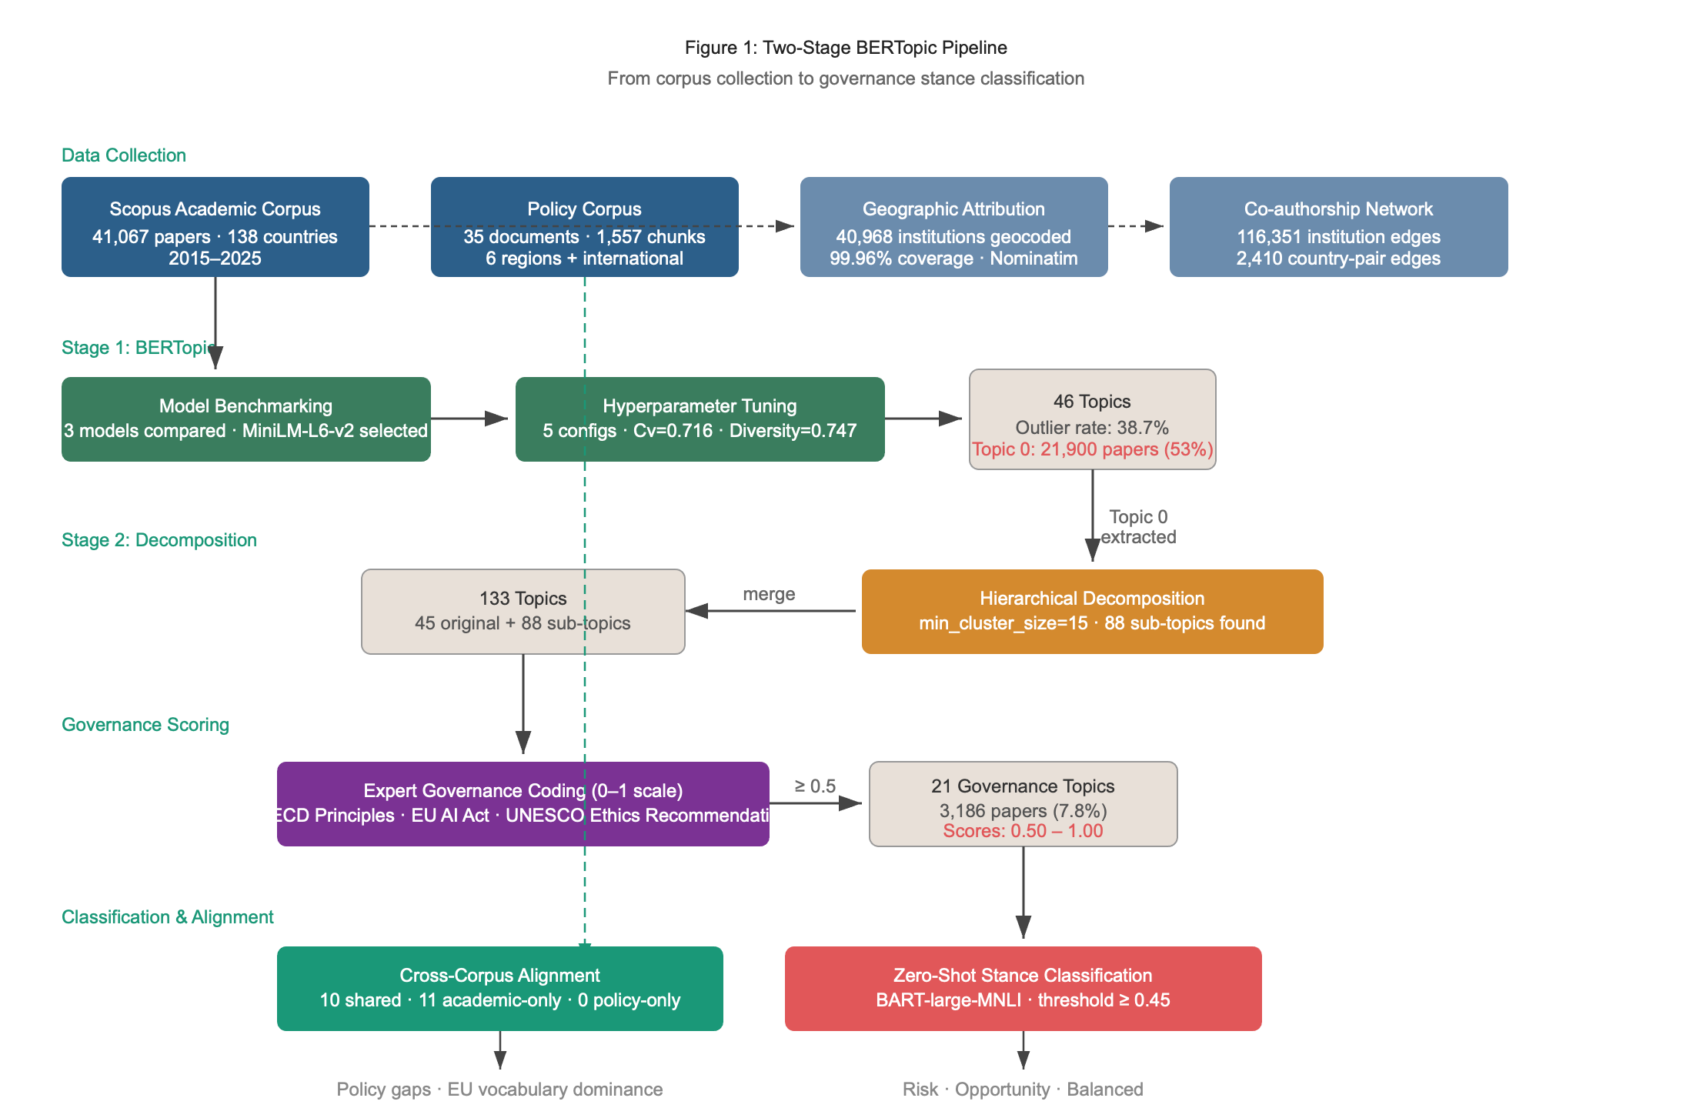
Figure 1: Two-stage BERTopic workflow from corpus to 133 topics
Each topic was assessed for governance relevance using expert coding on a 0–1 scale, based on keyword inspection and alignment with the OECD AI Principles (OECD, 2019), EU AI Act risk categories (European Parliament, 2024), and UNESCO Ethics Recommendation (UNESCO, 2021). Topics scoring ≥ 0.5 were classified as governance-relevant, yielding 21 topics and a governance corpus of 3,186 papers (7.8% of the full corpus).
3.4 Stance Classification
Zero-shot stance classification was applied to the 3,186 governance abstracts using BART-large-MNLI (Lewis et al., 2020). Zero-shot NLI was selected over supervised approaches because no labeled training dataset exists for this specific task, and because zero-shot models demonstrate strong domain-specific performance without fine-tuning (Yin et al., 2019). Each abstract was classified against three candidate labels: risk-focused, opportunity-focused, and balanced, using the highest-scoring label. Where the model’s top confidence score fell below 0.45, the paper was assigned to the balanced category to avoid propagating low-confidence predictions. This conservative design choice may modestly inflate the balanced count.
4. RESULTS
4.1 Dominant Governance Themes (RO1)
Of 41,067 AI publications, 3,186 (7.8%) address governance themes. The 21 governance topics span a spectrum from core regulatory concerns (EU AI Regulation, score = 1.0; Algorithmic Fairness, score = 1.0) to more peripheral governance implications (Digital Transformation, score = 0.55). The largest topic is AI Law, Ethics, and Human Rights (986 papers), followed by AI Cybersecurity and IoT Threats (429), and Generative AI and Creative Ethics (302). The top five topics account for 64.7% of the governance corpus.
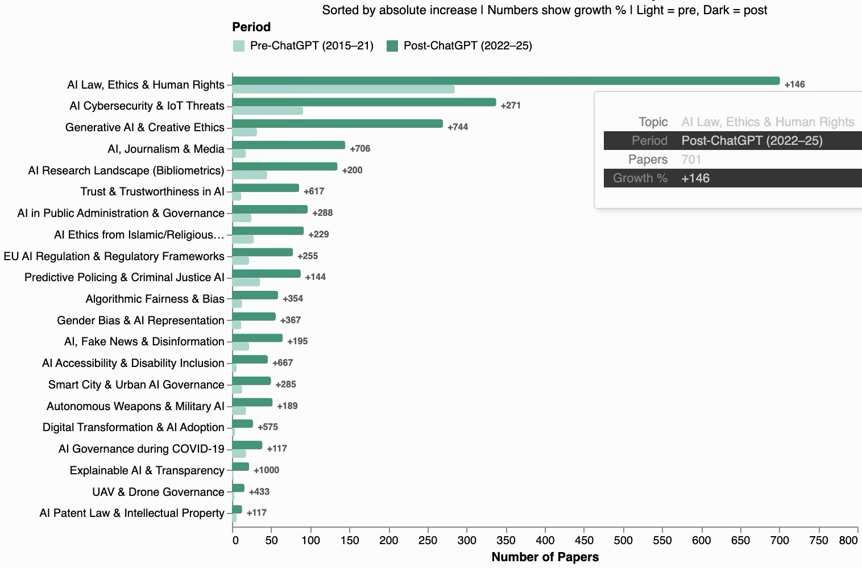
Figure 2: Pre- and post-ChatGPT governance research output by topic.
As shown in Figure 2, temporal analysis reveals pronounced post-ChatGPT growth across governance themes. In absolute terms, AI and Journalism/Media research grew by 706% between the pre- and post-ChatGPT periods; Trust and Trustworthiness in AI by 617%; Gender Bias and AI Representation by 367%; and Algorithmic Fairness and Bias by 354%. After controlling for the fourfold expansion of overall AI publication volume between periods, Journalism/Media (100%) and Trust (73%) retained substantial proportional growth, indicating genuine increases in governance attention rather than artifacts of field-wide expansion. Gender Bias (13%) and Algorithmic Fairness (12%) grew more modestly in proportional terms, suggesting their absolute increases largely tracked the broader field.
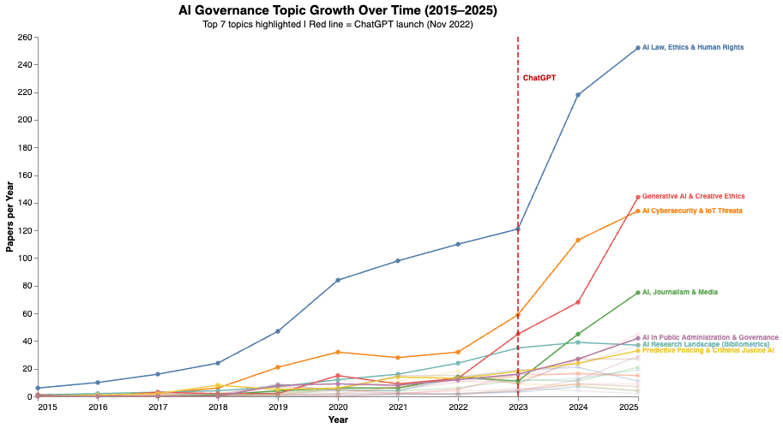
Figure 3: Governance topic growth trajectories (2015–2025)
Figure 4 disaggregates these trajectories across all 21 governance topics. Several distinct temporal patterns emerge. AI Law, Ethics and Human Rights, and AI Cybersecurity show sustained pre-ChatGPT growth that accelerated further post-2022. Generative AI and Creative Ethics is almost entirely a post-ChatGPT phenomenon, rising from near-zero to the third-largest governance topic. AI Governance during COVID-19 exhibits a characteristic spike-and-plateau pattern, peaking in 2021–2022 before declining — evidence of a transient governance concern tied to a specific crisis. At the other end of the spectrum, topics such as UAV and Drone Governance and AI Patent Law remain small throughout the period, suggesting these governance domains have yet to attract sustained scholarly attention.
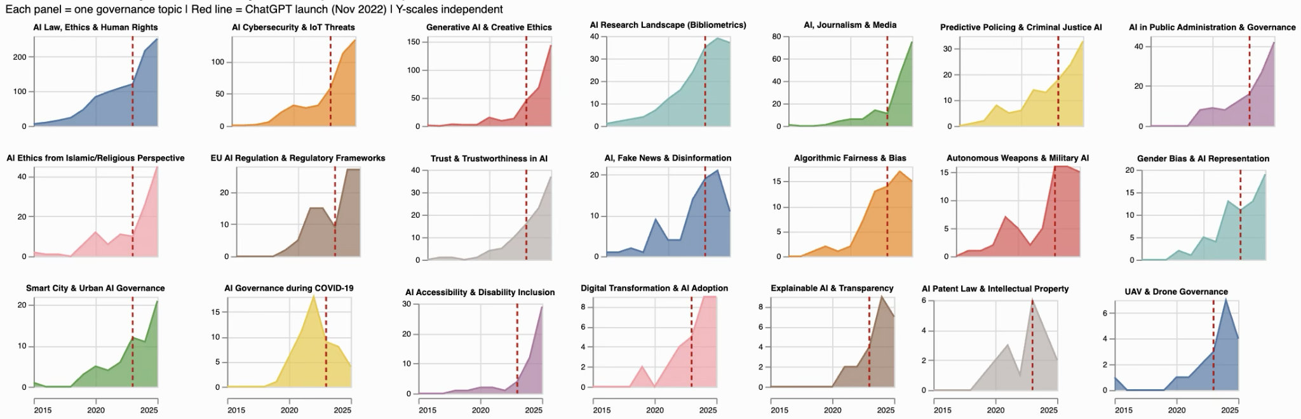
Figure 4: AI governance topic growth trajectories (2015–2025)
4.2 Stance Framing (RO1, continued)
Overall, 37.7% of governance papers are opportunity-focused, 30.6% risk-focused, and 31.7% balanced. The temporal breakdown reveals a significant framing shift: in the pre-ChatGPT period, balanced framing led (35.4%), with risk (34.9%) exceeding opportunity (29.7%); in the post-ChatGPT period, opportunity-focused papers rose to 40.0%, surpassing both balanced (30.7%) and risk-focused (29.4%). The paradox, that heightened governance urgency was accompanied by more optimistic framing, suggests researchers reoriented toward constructive institutional design rather than problem identification.
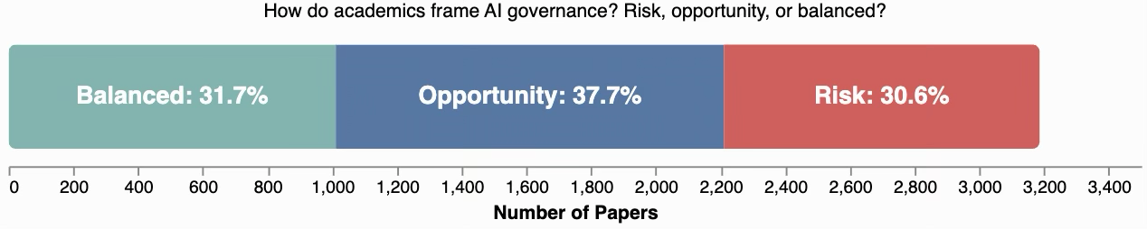
Figure 5: Overall governance stance distribution (n = 3,186)

Topic-level stance distributions show considerable variation. Autonomous Weapons and Military AI is the most risk-focused topic (72.9% risk), followed by EU AI Regulation (51.0%) and Algorithmic Fairness (48.6%). At the other extreme, AI Accessibility and Disability Inclusion (78.8% opportunity-focused), Smart City Governance (74.6%), and Digital Transformation (74.2%) are strongly opportunity-framed.
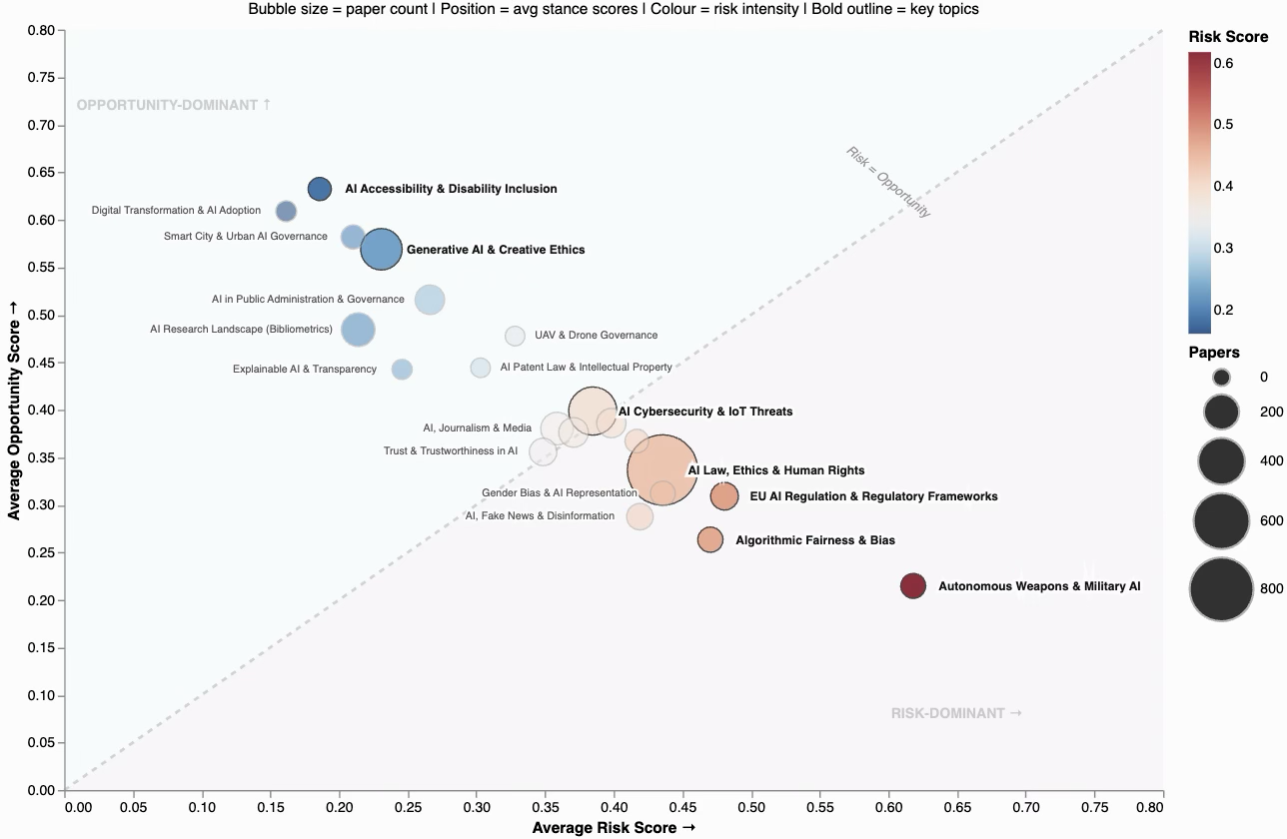
Figure 6: Governance topics: risk versus opportunity framing
4.3 Spatial Distribution (RO2)
Europe contributes the largest absolute share of governance papers (1,240, 38.9%), followed by Asia-Pacific (892, 28.0%), North America (510, 16.0%), Africa and the Middle East (289, 9.1%), Latin America (136, 4.3%), with 119 papers (3.7%) unclassifiable by region.
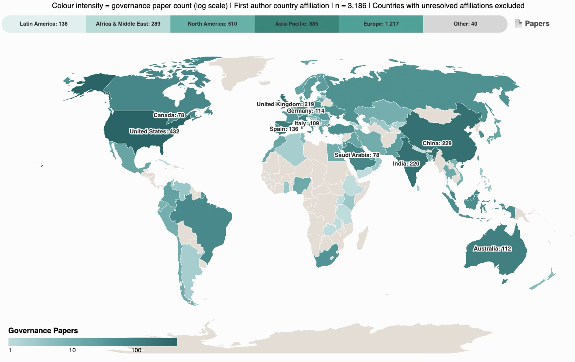
Figure 7: Global distribution of AI governance research (2015–2025)
Thematic specialization varies markedly across regions. Africa and the Middle East produce 2.02% of their total AI output on cybersecurity governance, more than three times the European rate (0.63%), a pattern consistent with the region’s specific threat landscape and digital infrastructure vulnerabilities. Latin America leads all regions on AI and Journalism/Media (0.92% of regional output), likely connected to the region's acute experiences of political disinformation. North America and Europe dominate Algorithmic Fairness research (0.43% and 0.24% respectively), reflecting strong civil rights and anti-discrimination traditions.
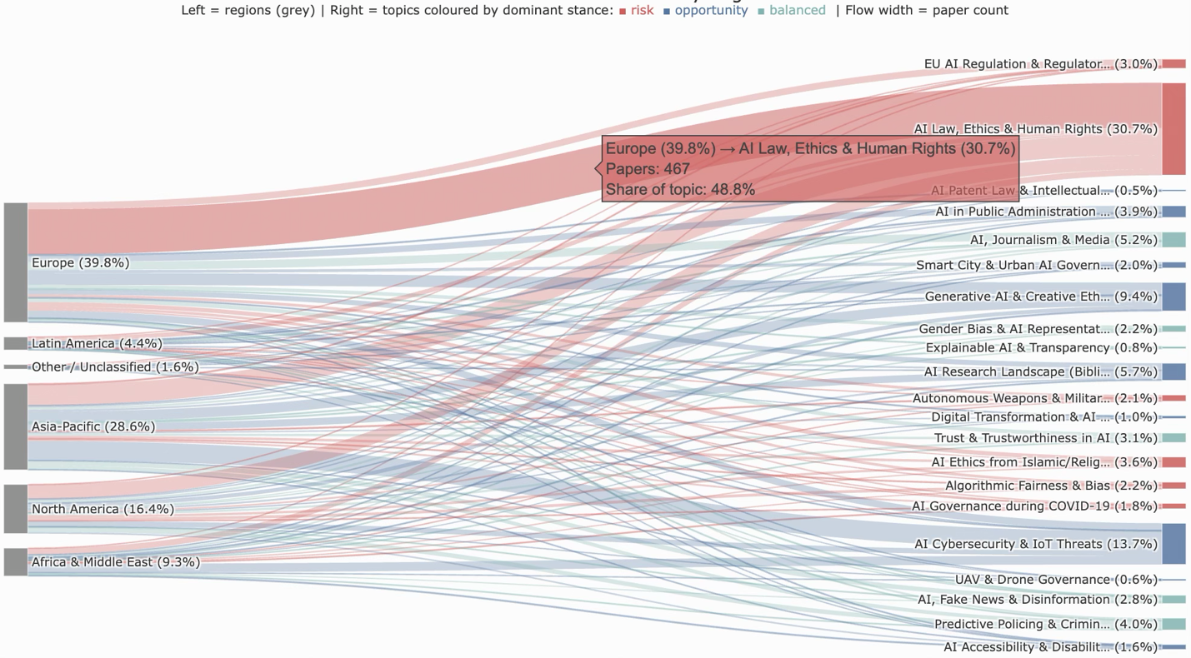
Figure 8: Governance research focus by region
Regional differences extend beyond thematic focus to how governance is framed. Opportunity-focused framing dominates in four of five regions: Africa and the Middle East (45.0%), Latin America (41.9%), Asia-Pacific (40.4%), and Europe (35.3%). North America is the sole exception, where balanced framing leads (35.7%), and risk framing (31.8%) exceeds that of any region except Europe (33.3%). The finding that Africa and the Middle East, despite concentrating on cybersecurity, a domain typically associated with threat, frame governance most optimistically suggests that regional framing reflects broader orientations toward AI as a development opportunity rather than being determined by topic choice alone.
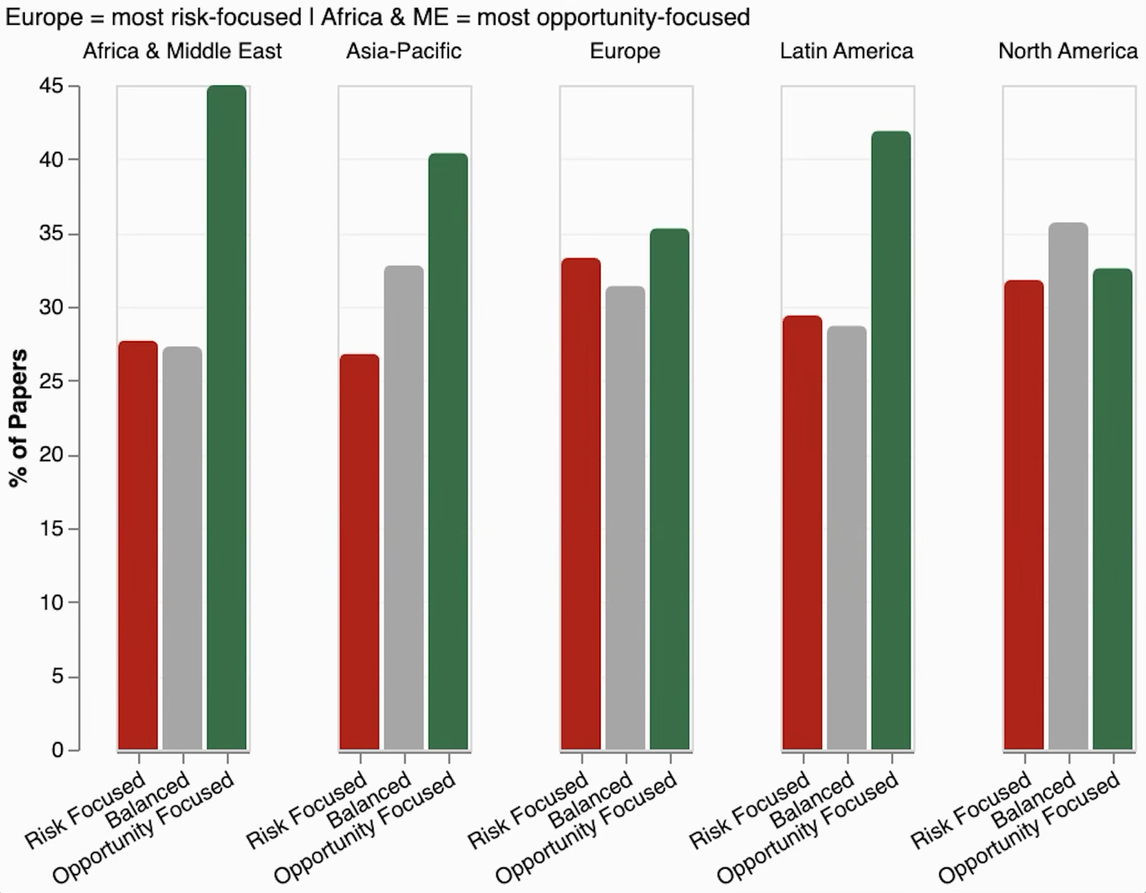
Figure 9: AI governance stance by world region
International co-authorship analysis reveals that AI research collaboration is concentrated in a small number of bilateral partnerships. China–United States (3,691 co-authored papers), United Kingdom–United States (2,336), and Canada–United States (2,245) are the three largest country-pair collaborations across the full corpus of 2,410 international edges. The United States functions as the dominant hub, appearing in the top six pairs. Cross-regional collaboration involving Africa, the Middle East, or Latin America remains comparatively limited, as Figure 10 illustrates. The densest arcs connect North America, Europe, and the Asia-Pacific, with few visible connections to the Global South.
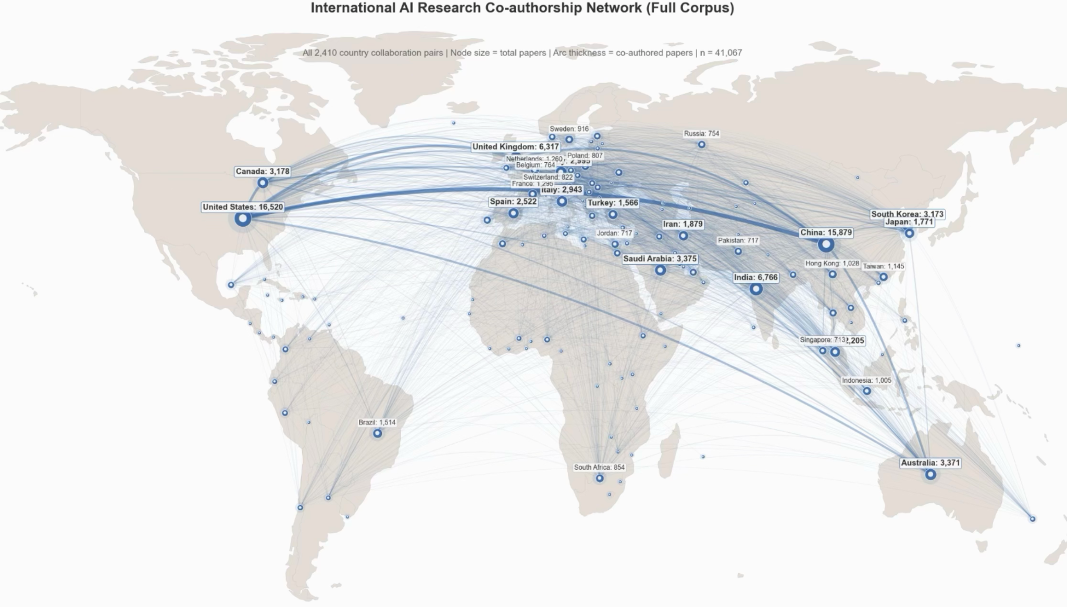
Figure 10: International AI collaboration across the broader AI corpus
Figure 11 below maps institution-level co-authorship across governance papers. The University of Oxford, University of Cambridge, and London School of Economics emerge as central European nodes; O.P. Jindal Global University and Chitkara University appear as prominent Asian hubs; and the University of Maryland represents a key North American contributor. The clustering structure reveals distinct regional and thematic communities, with European institutions forming dense interconnected networks while Global South institutions tend to occupy more peripheral positions, consistent with the country-level patterns observed above.

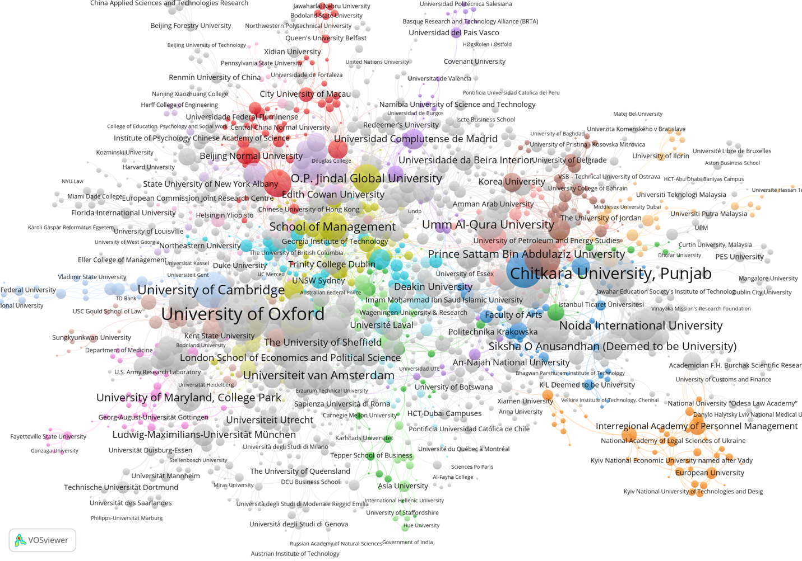
Figure 11: Institution co-authorship network
4.4 Academic versus Policy Alignment (RO3)
Of 21 governance topics, 10 are shared across both academic and policy corpora, 11 are academic-only, and none are policy-only — meaning every governance concern in national AI strategies is also present in academic discourse, but a substantial portion of academic governance scholarship has not been translated into formal policy attention.

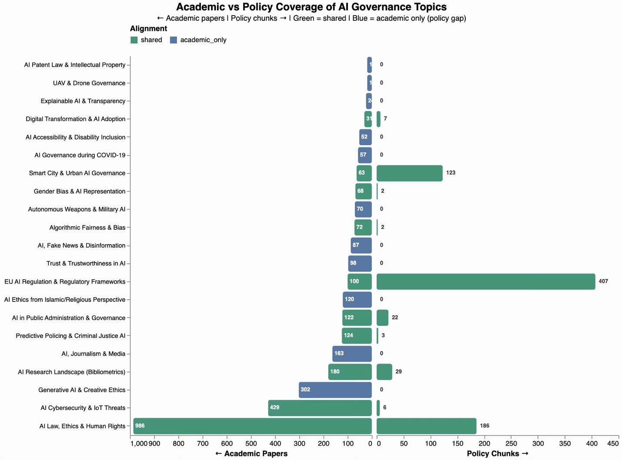
Figure 12: Academic Vs. Policy coverage of AI governance topics
Figure 10 illustrates the divergence in depth of engagement between the two corpora across the 10 shared topics. Of these, eight are led by academic discourse, most dramatically AI Cybersecurity (429 papers vs 6 policy chunks) and AI Law, Ethics and Human Rights (986 vs 186). Only two topics show greater policy than academic engagement: EU AI Regulation (407 policy chunks vs 100 academic papers) and Smart City Governance (123 vs 63) — domains where governments have moved ahead of academic discourse. The width of the gap reveals that sharing a topic label does not imply comparable depth of treatment.

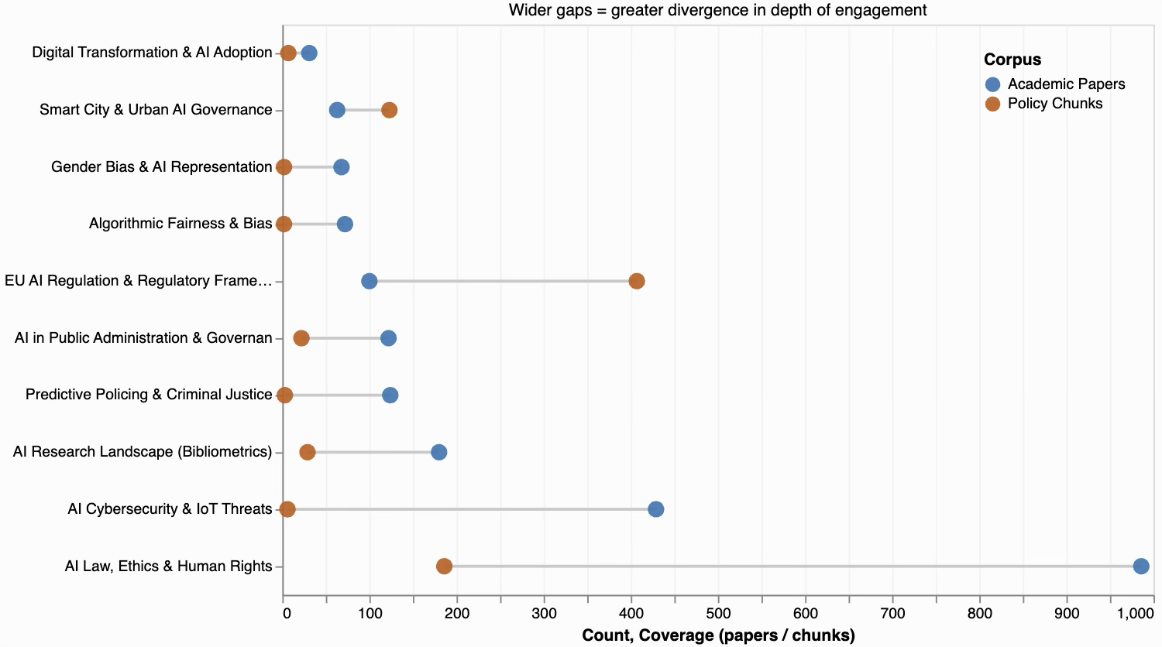
Figure 13: Coverage Gap (shared topics)
The 11 academic-only topics constitute a substantive governance gap. Absent from all national AI strategies are: Generative AI and Creative Ethics (302 papers), AI and Journalism/Media (163), AI Ethics from Islamic/Religious Perspective (120), Trust and Trustworthiness in AI (98), AI and Fake News/Disinformation (87), Autonomous Weapons and Military AI (70), and Explainable AI and Transparency (24).
These absences are not homogeneous in character and warrant distinction. The absence of Autonomous Weapons and Military AI reflects a deliberate scoping decision: the EU AI Act explicitly excludes military and national security applications from its provisions (European Parliament, 2024, Article 2(3)), and most national AI strategies similarly treat defense AI as a separate governance domain. This represents a genuine and consequential policy silence. By contrast, the absence of Trust and Trustworthiness in AI and fake news/Disinformation from policy chunk assignments is more plausibly a product of vocabulary divergence: policy frameworks address these concerns extensively, but under different terminology; trustworthy AI, synthetic media transparency, and human oversight, which did not trigger matches to academic topic clusters whose representative keywords are drawn from a different register. This distinction between deliberate exclusion and terminological misalignment is itself a substantive finding about how academic and policy communities engage with shared governance challenges through non-overlapping vocabularies.
A striking finding concerns the dominance of EU regulatory vocabulary. Documents from Zimbabwe (100% of chunks), the African Union (100%), India (100%), Kenya (97%), and ASEAN member states (98%) all align primarily to the EU AI Regulation topic despite no binding obligation to adopt European standards. The UAE (100%) similarly mirrors EU vocabulary, suggesting the pattern extends beyond former colonial relationships. Notably, this convergence is not universal: China, Australia, Japan, South Korea, Colombia, and Egypt show zero alignment with the EU Regulation topic, indicating these countries have developed governance vocabularies independent of the European framework. This bifurcation between countries that have adopted EU regulatory language wholesale and those that have not extends Bradford’s (2020) Brussels effect argument to AI governance discourse specifically, while also revealing its limits.

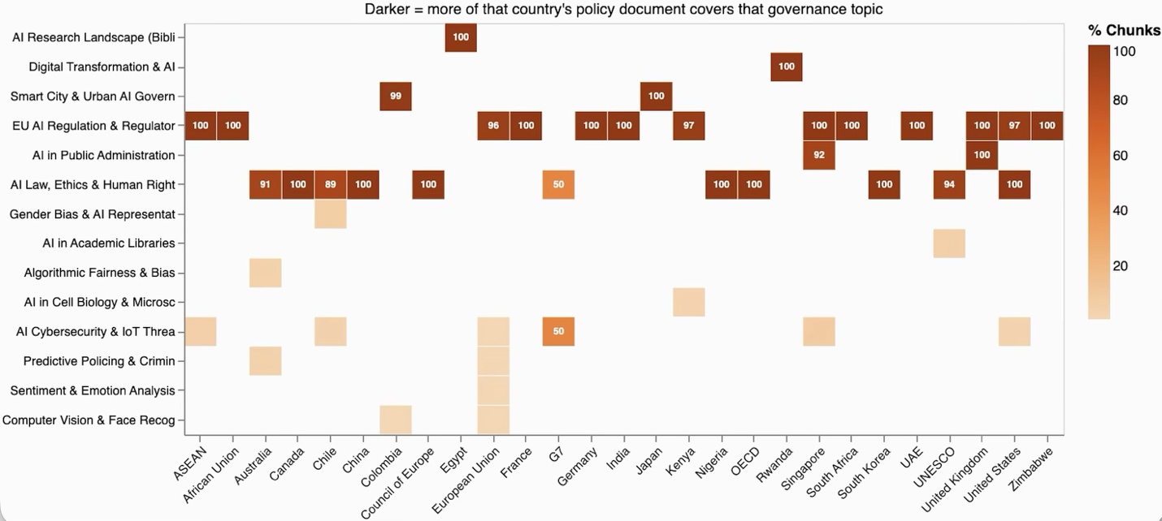
Figure 14: National AI policy topic coverage

5. DISCUSSION
5.1 The ChatGPT Paradox
The finding that post-ChatGPT governance research shifted toward opportunity framing even as volume surged is counterintuitive. One reading is that researchers concluded that generative AI, properly governed, offers substantial societal benefits and that governance should be oriented toward enabling these benefits while restricting harms, consistent with the framing of documents such as the UK AI Opportunities Action Plan (DSIT, 2025). A more cautious interpretation notes that many topics newly prominent post-ChatGPT: journalism, trust, disinformation, engage with governance challenges commonly associated with risk in public discourse. Yet within the academic literature, only disinformation is notably risk-leaning (37.9% risk vs 9.2% opportunity); journalism and trust are predominantly balanced in their framing. The framing shift may therefore reflect a maturation of governance scholarship toward constructive institutional design rather than complacency about risks. Disentangling these interpretations requires full-text analysis beyond abstract-level classification, a limitation acknowledged in Section 5.5.
5.2 Regional Asymmetries and Governance Knowledge
The pronounced regional differences in governance topic specialization are not random; they reflect the material conditions, institutional histories, and political economies that shape the governance questions different regions ask of AI systems. Africa and the Middle East’s disproportionate focus on cybersecurity, more than three times the European rate, plausibly reflects acute threat landscapes and limited regulatory capacity for proactive governance. Latin America’s leadership in journalism and media AI, with the highest proportional engagement of any region, is linked to well-documented regional experiences of political disinformation and media fragility. North America and Europe's dominance of fairness and bias research reflects civil rights and anti-discrimination legal traditions that have structured how AI harms are conceptualized in these regions.
These thematic differences are accompanied by differences in framing. Africa and the Middle East frame governance most optimistically despite its cybersecurity focus, while North America, the only balanced-dominant region, exhibits the most cautious orientation. This suggests that regional framing reflects broader institutional and developmental contexts rather than topic composition alone. Critically, the dominance of certain governance concepts in the academic literature should not be treated as evidence of their universal salience. Different vocabularies for articulating AI-related harms may exist across regions that are not captured in an English-language academic corpus, a limitation that future multilingual analyses should address.
5.3 The Knowledge-Policy Gap
The identification of eleven governance themes absent from national AI strategies raises fundamental questions about the channels through which research knowledge informs governance. The absence of autonomous weapons from all national AI strategies, despite 70 academic papers specifically addressing their governance, suggests either that defense and AI governance operate as separate policy domains or that the political sensitivity of lethal autonomous systems discourages their inclusion in documents projecting national AI ambition. As discussed in Section 4.4, this exclusion aligns with the EU AI Act’s explicit exemption of military applications (European Parliament, 2024, Article 2(3)). The absence of AI and disinformation is similarly troubling: with 87 academic papers engaging this governance challenge and zero policy chunks matching the topic, the gap cannot be explained by limited awareness. However, as noted in the limitations, this absence may partly reflect vocabulary divergence; policy documents address disinformation under terminology such as synthetic media and content authenticity, rather than genuine policy silence.

5.4 EU Regulatory Hegemony and Governance Pluralism
The finding that Global South policy documents structurally mirror EU AI Act vocabulary raises important questions about the emerging global governance architecture. Bradford (2020) argued that the Brussels effect propagates EU standards globally through market access conditions. The present findings extend this mechanism to conceptual vocabulary: countries with limited direct EU economic integration are nonetheless adopting EU regulatory frameworks as their baseline. Yet as the results demonstrate, this convergence is not universal; a divergence exists between countries that have adopted EU regulatory language wholesale and those that have developed independent governance vocabularies. Whether the convergence observed represents genuine normative alignment or discursive compliance without substantive enforcement requires further investigation. What the analysis establishes is that the conceptual vocabulary available to policymakers globally has been substantially structured by a single regulatory tradition, one developed in a high-income European context. If EU risk categories reflect European institutional priorities and vulnerability distributions, their global diffusion may produce governance frameworks formally coherent but substantively misaligned with diverse regional contexts.

This discursive influence is all the more striking given the mounting implementation challenges the EU AI Act faces domestically. Since its adoption in 2024, the Act has encountered delayed technical standards, with CEN-CENELEC missing its April 2025 deadline and now targeting late 2026; member state non-compliance, with many missing the August 2025 deadline to designate competent authorities; and political pressure to defer enforcement, culminating in the Commission's November 2025 Digital Omnibus proposal to delay high-risk system obligations until December 2027 (European Commission, 2025). Over 110 European companies, including Airbus, ASML, and Mistral, have formally requested a two-year enforcement postponement. The paradox is clear: a regulatory framework still struggling to achieve domestic implementation has already become the default vocabulary for AI governance across much of the Global South. This raises the possibility that what is diffusing globally is not a tested regulatory model but a regulatory aspiration, one whose practical viability remains unresolved even in its jurisdiction of origin.
5.5 Limitations and Future Research
Five limitations warrant acknowledgment. First, governance relevance scores involve expert judgment; though grounded in established taxonomies (OECD, EU AI Act, UNESCO), alternative scoring decisions might modestly alter topic composition. Second, policy chunk assignment used keyword-based matching for catch-all topic chunks, an approximation less precise than embedding-based methods. Third, abstract-level stance classification cannot capture the full argumentative complexity of individual papers. Fourth, the confidence threshold (0.45) reassigns low-confidence predictions to the balanced category; 808 papers (25.4%) fell below this threshold, which may modestly inflate balanced counts. Fifth, keyword-based cross-corpus alignment is sensitive to vocabulary divergence between academic and policy registers; topics such as Trust and Disinformation may appear in policy documents under different terminology without triggering matches to academic topic clusters. Future work should employ cross-register semantic alignment, full-text analysis, and human-coded validation of stance classifications.
6. CONCLUSIONS
This study provides the first spatially disaggregated, multi-corpus mapping of AI governance discourse, generating evidence on whose concerns are foregrounded and whose are neglected in the expert and policy conversations shaping AI regulation. In answer to RO1, only 7.8% of AI research addresses governance, a growing but still minority concern. Post-ChatGPT, governance scholarship surged in volume while shifting from a period in which risk framing exceeded opportunity framing (34.9% vs 29.7%) to one in which opportunity framing leads decisively (40.0% vs 29.4%), suggesting a reorientation toward institutional design. Topic-level stance analysis reveals systematic variation: autonomous weapons (72.9% risk) and regulatory compliance are strongly risk-dominated, whereas accessibility (78.8% opportunity), smart cities, and digital transformation are opportunity-framed.
In answer to RO2, pronounced regional specialization reflects distinct vulnerability profiles and institutional contexts. Africa and the Middle East’s cybersecurity focus, Latin America’s journalism leadership, and Europe and North America’s fairness dominance are structured patterns rather than random distributions. Regions also differ in how they frame governance: opportunity framing dominates in four of five regions, with North America the sole balanced-dominant exception. International governance collaboration is heavily concentrated in a small number of bilateral partnerships: China–United States (3,691), United Kingdom–United States (2,336), and Canada–United States (2,245), raising questions about the geographic reach of governance knowledge production.
In answer to RO3, eleven governance themes present in academic discourse, including autonomous weapons (70 papers), disinformation (87 papers), and public trust (98 papers), are absent from national AI strategies, though some absences may reflect vocabulary divergence rather than genuine policy silence. EU regulatory vocabulary has achieved substantial but not universal dominance, structuring policy discourse in several Global South jurisdictions while remaining absent from the frameworks of others. Together, these findings suggest that the emerging global AI governance architecture risks systematically marginalizing both the concerns of non-European regions and the insights of academic scholarship that have not yet been translated into policy.
The pipeline is published as an open-source repository designed for ongoing monitoring. As new publications and policy documents emerge, they can be transformed by the fitted model to track the evolution of governance discourse in near real-time, a resource we offer to researchers, policymakers, and civil society organizations engaged with the global AI governance landscape.
REFERENCES
Bietti, E. (2020). From ethics washing to ethics bashing: A view on tech ethics from within moral philosophy. Proceedings of the 2020 Conference on Fairness, Accountability, and Transparency, 210–219. https://doi.org/10.1145/3351095.3372860
Blei, D. M., Ng, A. Y., & Jordan, M. I. (2003). Latent Dirichlet Allocation. Journal of Machine Learning Research, 3(Jan), 993–1022.
Bradford, A. (2020). The Brussels effect: How the European Union rules the world. Oxford University Press. https://books.google.com/books?hl=en&lr=&id=mZXHDwAAQBAJ&oi=fnd&pg=PP1&dq=Bradford,+A.+(2020).+The+Brussels+Effect:+How+the+European+Union+Rules+the+World.+Oxford+University+Press&ots=D_5jCQ1YIN&sig=SLzFHOorWz5txPdsbK-9cFRsJXs
Corrêa, N. K., Galvão, C., Santos, J. W., Del Pino, C., Pinto, E. P., Barbosa, C., Massmann, D., Mambrini, R., Galvão, L., & Terem, E. (2023). Worldwide AI ethics: A review of 200 guidelines and recommendations for AI governance. Patterns, 4(10). https://www.cell.com/patterns/fulltext/S2666-3899(23)00241-6
DSIT. (2025). AI Opportunities Action Plan. GOV.UK. https://www.gov.uk/government/publications/ai-opportunities-action-plan
Dwivedi, Y. K., Kshetri, N., Hughes, L., Slade, E. L., Jeyaraj, A., Kar, A. K., Baabdullah, A. M., Koohang, A., Raghavan, V., & Ahuja, M. (2023). Opinion Paper:“So what if ChatGPT wrote it?” Multidisciplinary perspectives on opportunities, challenges and implications of generative conversational AI for research, practice and policy. International Journal of Information Management, 71, 102642.
Egger, R., & Yu, J. (2022). A topic modeling comparison between lda, nmf, top2vec, and bertopic to demystify twitter posts. Frontiers in Sociology, 7, 886498.
Entman, R. M. (1993). Framing: Towards clarification of a fractured paradigm. McQuail’s Reader in Mass Communication Theory, 390, 397.
Eubanks, V. (2018). Automating inequality: How high-tech tools profile, police, and punish the poor. Macmillan+ ORM. https://books.google.com/books?hl=en&lr=&id=pn4pDwAAQBAJ&oi=fnd&pg=PT6&dq=Eubanks,+V.+(2018).+Automating+Inequality:+How+High-Tech+Tools+Profile,+Police,+and+Punish+the+Poor.+New+York:+St.+Martin%27s+Press.&ots=gF3KLjeuvd&sig=kS-OrPlaEG3ANrV835JcI-mnR_0
European Parliament. (2024). Regulation (eu) 2024/1689 of the european parliament and of the council. Regulation (Eu). http://hctinsight.com/webzine/webzine/202501/file/ce/ce5.pdf
Ferjani, I., Alzahrani, F. A., & Bouzir, N. M. (2025). Navigating Responsible AI: A Systematic Review of Governance Mechanisms and Future Co-Governance Scenarios. Procedia Computer Science, 270, 4726–4735.
Grootendorst, M. (2022). BERTopic: Neural topic modeling with a class-based TF-IDF procedure (arXiv:2203.05794). arXiv. https://doi.org/10.48550/arXiv.2203.05794
Hagendorff, T. (2020). The Ethics of AI Ethics: An Evaluation of Guidelines. Minds and Machines, 30(1), 99–120. https://doi.org/10.1007/s11023-020-09517-8
Jobin, A., Ienca, M., & Vayena, E. (2019). The global landscape of AI ethics guidelines. Nature Machine Intelligence, 1(9), 389–399. https://doi.org/10.1038/s42256-019-0088-2
Klinger, J., Mateos-Garcia, J., & Stathoulopoulos, K. (2021). Deep learning, deep change? Mapping the evolution and geography of a general purpose technology. Scientometrics, 126(7), 5589–5621.
Lewis, M., Liu, Y., Goyal, N., Ghazvininejad, M., Mohamed, A., Levy, O., Stoyanov, V., & Zettlemoyer, L. (2020). BART: Denoising sequence-to-sequence pre-training for natural language generation, translation, and comprehension. Proceedings of the 58th Annual Meeting of the Association for Computational Linguistics, 7871–7880. https://aclanthology.org/2020.acl-main.703/
Mittelstadt, B. (2019). Principles alone cannot guarantee ethical AI. Nature Machine Intelligence, 1(11), 501–507.
Navaratna, A., & Saxena, D. (2025). National AI Policy: Keyword and Topic Modelling Analysis. 2025 IEEE Guwahati Subsection Conference (GCON), 1–5. https://ieeexplore.ieee.org/abstract/document/11173368/
Nisbet, M. C. (2009). Communicating Climate Change: Why Frames Matter for Public Engagement. Environment: Science and Policy for Sustainable Development, 51(2), 12–23. https://doi.org/10.3200/ENVT.51.2.12-23
Noble, S. U. (2018). Algorithms of Oppression: How Search Engines Reinforce Racism. New York University Press. https://doi.org/10.18574/nyu/9781479833641.001.0001
OECD. (2019). Recommendation of the council on artificial intelligence. Organization for Economic Cooperation and Development.
OECD. (2025). OECD.AI Policy Observatory. Organisation for Economic Co-operation and Development [Online post]. https://oecd.ai
Reimers, N., & Gurevych, I. (2019). Sentence-bert: Sentence embeddings using siamese bert-networks. Proceedings of the 2019 Conference on Empirical Methods in Natural Language Processing and the 9th International Joint Conference on Natural Language Processing (EMNLP-IJCNLP), 3982–3992. https://aclanthology.org/D19-1410/
Röder, M., Both, A., & Hinneburg, A. (2015). Exploring the Space of Topic Coherence Measures. Proceedings of the Eighth ACM International Conference on Web Search and Data Mining, 399–408. https://doi.org/10.1145/2684822.2685324
Song, K., Tan, X., Qin, T., Lu, J., & Liu, T.-Y. (2020). Mpnet: Masked and permuted pre-training for language understanding. Advances in Neural Information Processing Systems, 33, 16857–16867.
Tahaei, M., Wilkinson, D., Frik, A., Muller, M., Abu-Salma, R., & Wilcox, L. (2024). Surveys considered harmful? Reflecting on the use of surveys in AI research, development, and governance. Proceedings of the AAAI/ACM Conference on AI, Ethics, and Society, 7(1), 1416–1433. https://ojs.aaai.org/index.php/AIES/article/view/31734
UNESCO. (2021). Recommendation on the ethics of artificial intelligence. United Nations Educational.
Waltman, L. (2016). A review of the literature on citation impact indicators. Journal of Informetrics, 10(2), 365–391.
Wang, W., Wei, F., Dong, L., Bao, H., Yang, N., & Zhou, M. (2020). Minilm: Deep self-attention distillation for task-agnostic compression of pre-trained transformers. Advances in Neural Information Processing Systems, 33, 5776–5788.
Yin, W., Hay, J., & Roth, D. (2019). Benchmarking zero-shot text classification: Datasets, evaluation and entailment approach. Proceedings of the 2019 Conference on Empirical Methods in Natural Language Processing and the 9th International Joint Conference on Natural Language Processing (EMNLP-IJCNLP), 3914–3923. https://aclanthology.org/D19-1404/

